Flagging Operations & Procedures
.

Flagging Operations:

Flagging operations are critical to moving traffic safely and expeditiously through or around road construction work areas. Flaggers are provided at work sites to stop traffic intermittently as necessitated by work in progress or to maintain continuous traffic past a work site at reduced speeds to help protect the work crew.

The following table includes some of the basic flagging operations to be followed on the job site.

Item | Yes | No
Stop/Slow paddle used as primary device
Paddles are 8-sided, 18 inches minimum (24 inches for high speeds)
Minimum 5 foot staff length, 6 foot preferred
Flags ok for emergencies/special situations
Flags are 24 inches, red color, solid material
Flagger procedure per MUTCD, strictly followed
All flaggers trained
Flaggers wear good quality orange vest, orange hard hat reflectorized at night
Flagger station isolated from operation, other workers
Good sight distance to flagger station
Flagger has adequate escape path
Flagger positioned at edgeline as traffic approaches
Flagger maintains eye contact until vehicle stopped
Periodic relief provided to all flaggers
Flagger sign in advance of full time flaggers
Flagger sign removed promptly when not needed
Distance from sign to flagger kept current
Other warning signs provided per MUTCD
Supplemental signs/devises to slow traffic on high-speed roads prior to flagger
Flagger station lighted at night (lighted wand and flares for emergencies)

Flagging Procedures:

The following methods of signaling with a flag should be used:

1. To Stop Traffic. The flagger shall face traffic and extend the flag horizontally across the traffic lane in a stationary position so that the full area of the flag is visible hanging below the staff. For greater emphasis, the free arm may be raised with the palm toward approaching traffic.

2. When it is Safe for Traffic to Proceed. The flagger shall stand parallel to the traffic movement, and with flag arm lowered from view of the driver, motion traffic ahead with free arm. Flags shall not be used to signal traffic to proceed.

3. Where it is Desired to Alert or Slow Traffic. Where it is desired to alert or slow traffic by means of flagging, the flagger shall face traffic and slowly wave the flag in a sweeping motion of the extended arm from the shoulder level to straight down without raising the arm above a horizontal position.

If a sign paddle is used, it shall be held in a stationary position with the arm extended horizontally away from the body. For added emphasis, the flagger may slowly raise and lower the free hand with the palm down,

The use of the flag and sign paddle are illustrated below:

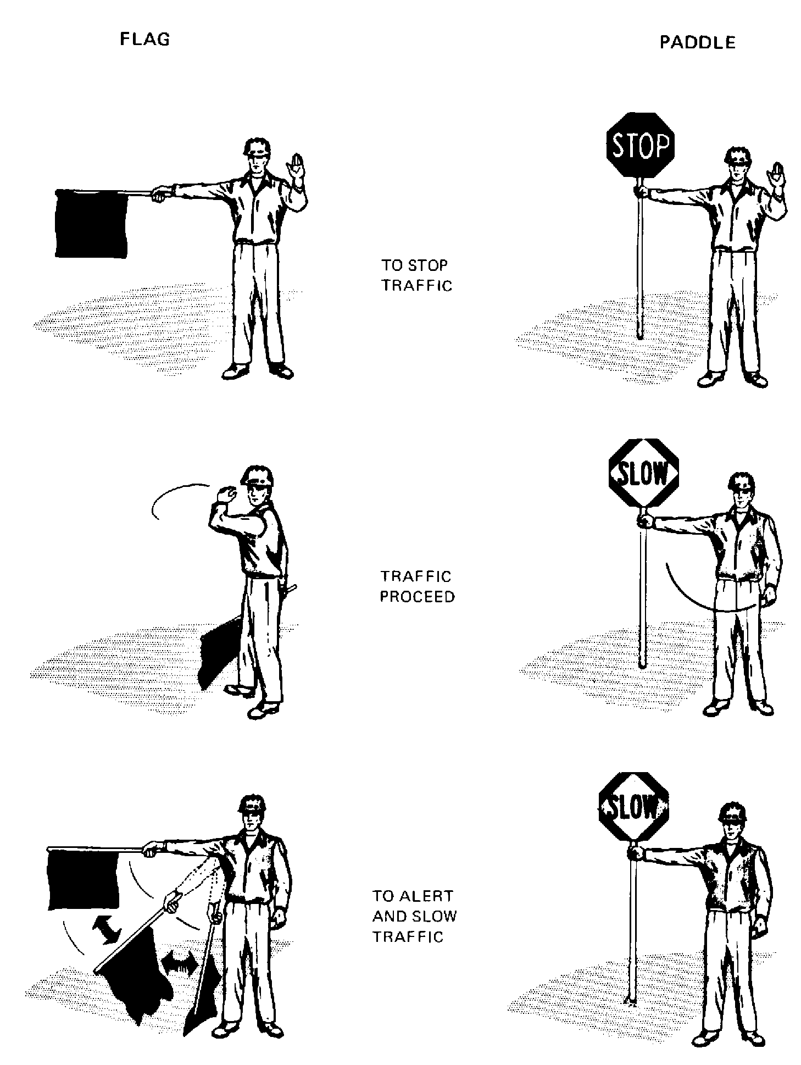

Field Inspection Checklist - Roadway Surface Conditions

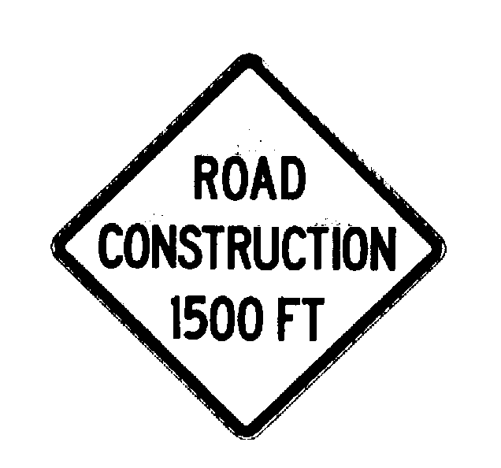

The construction zone needs to be carefully monitored under varying conditions of traffic volume, lighting conditions, and weather, to ensure that traffic control measures are operating effectively, and that all devices used are clearly visible, clean and in good repair. The maintenance of the roadway surface also requires constant attention during the life of the construction zone because of the potential increase in hazards.

The following table includes some of the basic conditions which should be continually monitored throughout the life of the construction zone in order to minize the potential for losses.

Item | Yes | No
Bumps/holes/rough pavement repaired promptly

Advanced warning signs for bumps, rough/unpaved surfaces

Warning signs for milled/grooved pavement

Restore pavement markings on milled pavement

Prevent accumulation of pavement debris -- sand/gravel/dust/oil/etc. by cleaning as necessary
Control dust on unpaved surfaces using water/chemicals

Maintain smooth surface on unpaved roadway by frequent grading/compaction

